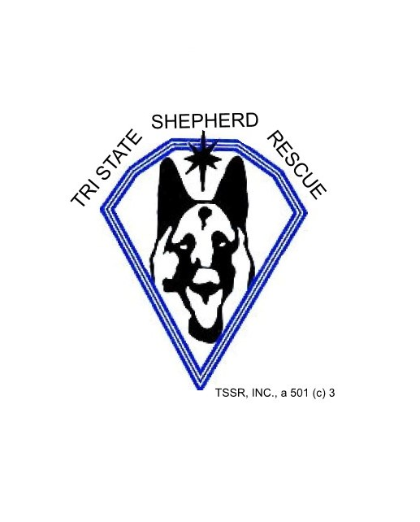
WILMINGTON, DE –Adoption Contract

I, __ ______________________________, do this ______day of__ _____, 20__24__, enter into this Adoption Contract and acknowledge receipt from Tri State Shepherd Rescue, Wilmington DE of the animal named and described as: ____ ______ ___________________ (Name),____________________ (ID#),_______G __________(Breed),_____________. Description Contribution fee: $__350.00____. I realize that there is a $25 fee for returned checks.

Kindly Make your check payable to Tri State Shepherd Rescue.

The adoption fee includes the following.

- Shelter Fees
- Initial examination – basic shots (age appropriate in puppies)
- Intestinal de-worming, flea treatment and other anti-parasite treatment as necessary
- Spaying or neutering (not for puppies – must be age appropriate)
- Boarding as necessary
- Dental work as necessary
- OTHER:____________________________________________________

Tri State Shepherd Rescue agrees to provide a dog that has been vaccinated (age appropriate), de-wormed, sterilized (if possible given health conditions as this is age and health dependent).

Tri State Shepherd Rescue agrees to provide medical records and a history of the dogs if known and as it is known to us, that we have noted or of which we have been informed.

I (the adopter) agree to these following terms and provisions:

- From the date of this contract, I agree to assume full responsibility for the veterinary care of this dog.
- I will provide this dog with humane care and daily care and maintenance in accordance with all current and future state, county and local laws and ordinances where I reside.
- I will provide this dog with necessary veterinary care upon sickness, disease and/or injury. I will take him or her to the veterinarian at least once a year for an examination and routine vaccinations and tests or more often if necessary.
- I agree to provide—at a minimum – the following vaccinations and tests at the intervals required by law or advised by my veterinarian: rabies, distemper/parvo combination, and a regular course of heartworm preventative as well as worming. I will keep the dog free of dangerous and irritating pests such as ticks and fleas.
- I will provide this dog with a fully fenced yard or other humane means of exercise. He or she shall not be kept outside in a yard, or constantly chained or tied outside. I will not leave the dog in an electronic containment system unsupervised.
- This dog will reside in my home, will be kept as a household pet, and will not be used for breeding, or exclusively as a hunting or guard dog. PLEASE INITIAL THIS CLAUSE_________

If, for any reason, I cannot keep this dog, I will notify Tri State, I will hold the dog in my custody and keep the dog healthy and safe, provide pictures and information to post for re-adoption and fully work with Tri State for finding the dog a new suitable home. I will return the dog to Tri State Shepherd Rescue. The dog will not be given away, surrendered, sold, or exchanged. I understand that any friend or family member who wishes to take ownership of this dog will be required to apply to Tri State Shepherd Rescue for the right to adopt it. PLEASE INITIAL THIS CLAUSE. _________
- I will provide a collar for the dog to wear at all times when allowed outdoor; the collar must have an identification tag, and or the dog shall have a microchip tag, a rabies tag, and a personal tag with your information on it.
- The dog will not be left unsupervised with other pets or children for the first month of adoption.
- I agree not to abuse or neglect the dog and I authorize Tri State Shepherd Rescue at their discretion, to determine whether or not the dog has been abuse or neglected. I shall under no circumstances physically punish the dog. Rather I will consult with Tri State Shepherd Rescue, my veterinarian and or any trainer about the appropriate ways of dealing with specific behavioral problems.
- The adopter will refrain from physical abuse and other inhumane treatment and will prevent other adults and children from teasing and physically abusing the dog.
- I understand I will only euthanize the dog for an untreatable, fatal medical condition, as attested to by a licensed veterinarian, with written notification submitted to Tri State Shepherd Rescue If the adopter feels it necessary to consider euthanizing the dog without the diagnosis of an untreatable medical condition, the adopter agrees to contact Tri State Shepherd Rescue for consultation prior to choosing this option. Euthanizing the dog means intentionally putting the animal to death by any method including gas and lethal injection, otherwise known as putting to sleep.
- I agree to provide notification to Tri State Shepherd Rescue within 14 days of any change of address, phone number or any circumstances that will affect the dog, as well as notice of any incident involving police, animal control, or SPCA.
- I agree not to permit the dog to ride in the back of an open pickup truck I agree not to leave the dog unattended in a vehicle at anytime. I also agree not to allow the dog be flown in an airplane without pressurized and climate control hold areas or when the temperature at either departure or landing is above 60 or below 45 degrees.
- I agree, from the date of this contract, to release and indemnify Tri State Shepherd Rescue from any and all claims, known or unknown, now or hereafter arising in connection with this dog.
- I consent to the examination of this dog by Tri State Shepherd Rescue at any time and acknowledge that Tri State Shepherd Rescue has the right to reclaim the dog at any time for failure to comply with the terms of this contract or for any misrepresentations of fact made on the adoption application or in this contract.
- I agree to pay Tri State Shepherd Rescue for any and all expenses, including court costs and reasonable attorney’s fees, if legal action is necessary to enforce the terms and provisions of this contract.
- I understand that the Contribution Fee is non-refundable.

- I understand that this is a legal and binding contract and by my signature agree to all of the terms herein.
Adopter Signature:____________________________________________________________________________

Drivers License No.__________________________________________________Exp:

Adopter Name (Printed):_____________________________________________________________________________

Tri State Shepherd Rescue Representative: __________________________________

Date: ________________

The officers and volunteers of Tri State Shepherd Rescue remain interested in the welfare and well-being of your dog and his or her new family. Please contact us if you have any questions or concerns especially in the adjustment phase. News of your dog and photographs are always greatly appreciated. Please consider us part of your extended family.

